Dear i-board user,

This topic continues our focus on numeracy, with a topic on ordinal numbers in PURPLE. All the activities have sound to support any written instructions.

Ordinal  Aliens | Numeracy  Use ordinal numbers in different contexts
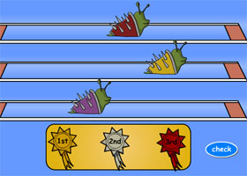 | Racing Snails:  Start the alien snails racing and award 1st, 2nd and 3rd place rosettes.
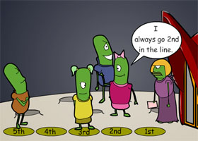 | Lining Up:  When the alien teacher tells the children to line up, they each ask to be in a certain ordinal position. Order the alien schoolchildren in their appropriate positions in the line.
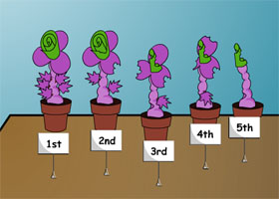 | Flower Show:  Use sequencing skills to re-arrange the flower pots and test your knowledge of ordinal numbers, in the alien flower show.
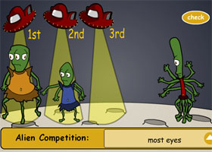 | Alien Competition:  Choose the criteria for your contest (from five different categories), then decide which positions the aliens should be placed in.
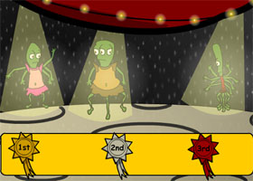 | Alien Teleport:  Watch carefully and remember which aliens teleport onto the planet first, second and third.

