“The Clock Struck ?” asks pupils to set the clock at different times to send the mouse scuttling down again.

Dear i-board user,

This month our topic focuses on different
aspects of TIME. It’s in RED.

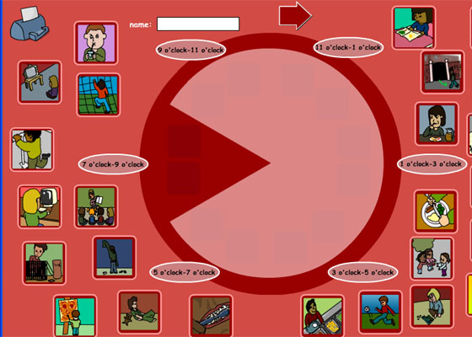 | 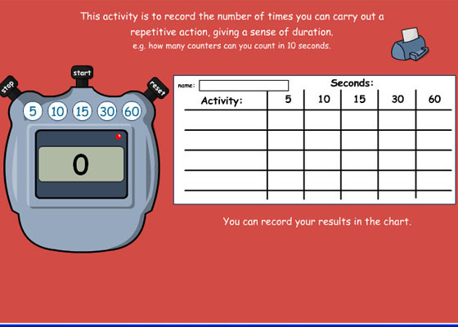
“My Day” allows the pupils to drag images to show how they spend their time, from morning to evening. | “How Long?” uses a countdown to time your pupils doing various activities. Use it to help pupils get a sense of duration.
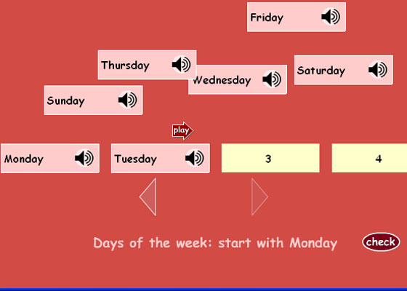 | 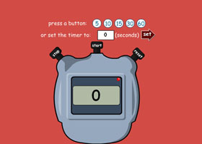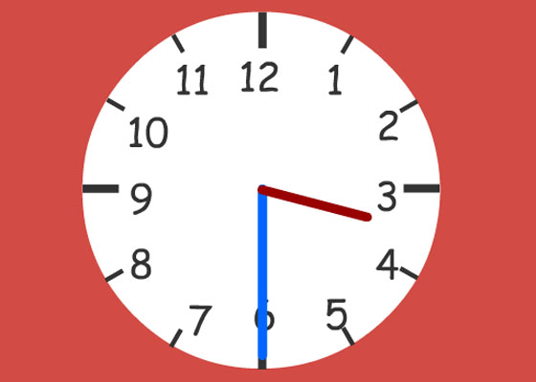
“Word Order” a straightforward tool that asks pupils to order words and reads back their list for self-checking. | “Stop Watch” and “Class Clock” – two useful whiteboard tools.

