Dear i-board user,
Our latest topic is ‘Weight and Capacity’, for numeracy in RED. Pupils explore the concepts of equal weight and of capacity, using both standard and non-standard measures. The focus is on estimating and testing. All are suitable for whiteboard or individual pupil use, with three activities creating printable reports as a useful assessment tool.

Weight and Capacity | Numeracy  Balance scales, fill containers, estimate and test
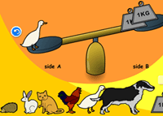 | Animal Balance:  An exploratory introduction to equal weight and balance, using kg weights and animals, on virtual scales. When balanced, the results can be saved to a printable report.
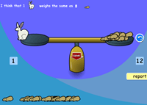 | Animal Estimate:  How many of one type of animal will equal the weight of another? Pupils make their estimate, then test on the virtual scales. Creates a printable report of estimates next to actual results.
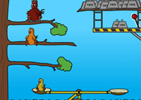 | Chicken Catapult:  A fun way to explore relative weight – how many weights are needed to propel the various-sized chickens onto the same branch?
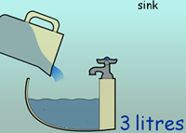 | Filling with Litres:  A straightforward activity, providing containers of various capacities to fill with a litre jug. Use on the whiteboard to gauge pupils’ estimation skills and understanding of capacity.
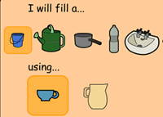 | Cup or Jug?:  Use non-standard measures (cup or jug) to fill various larger containers. Pupils must choose a container to fill, then decide whether the cup or jug is more appropriate to use to fill it. Creates a printable report.

